Vocabulary Review 2020
1. What are the following colours in English?
- Wapeyo

- Pkeyo

- Moskwancihte

- Alinchisewecihte

- Topkwancihte

- Mekeseweyo

- Sonapewecihte

- Stahkwencihte

- Wisaweyo

- Amwi Pkweyo

- Amwi Mekesweyo

Answer in W’last’kwey:
- What colour are your eyes?

- What is your favourite colour?

- What colour are your shoes?

- What colour is your shirt?
_________________________________________________________
KEHS ACIYE
What does Kehs Aciye mean?

What are the following times in Maliseet?
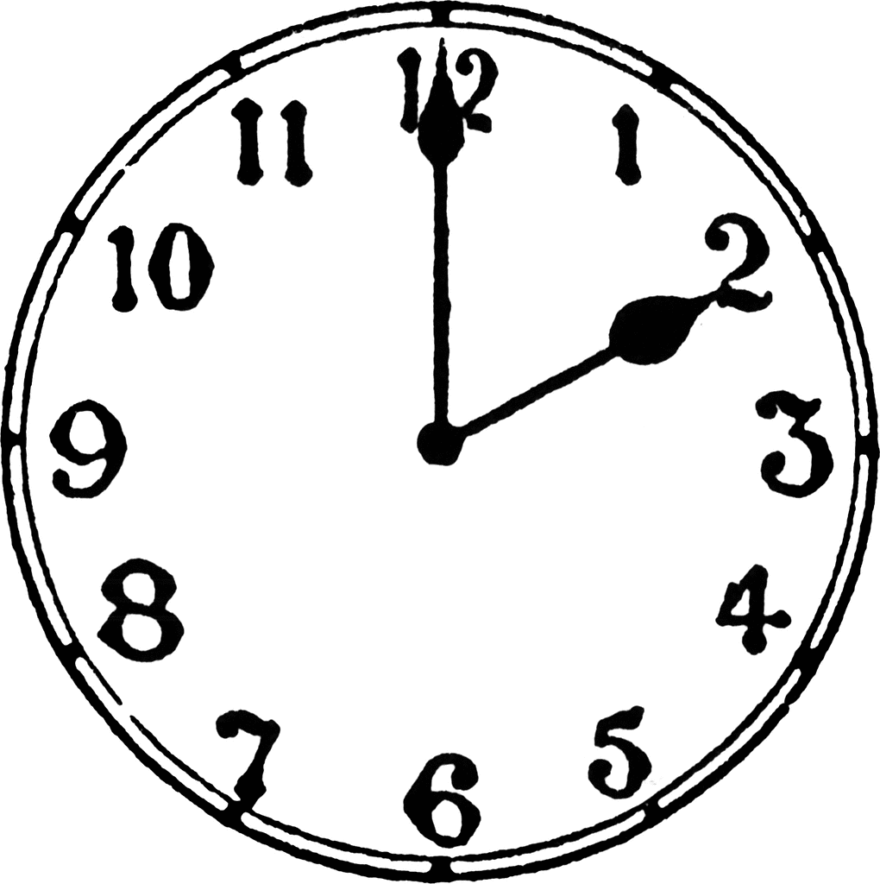

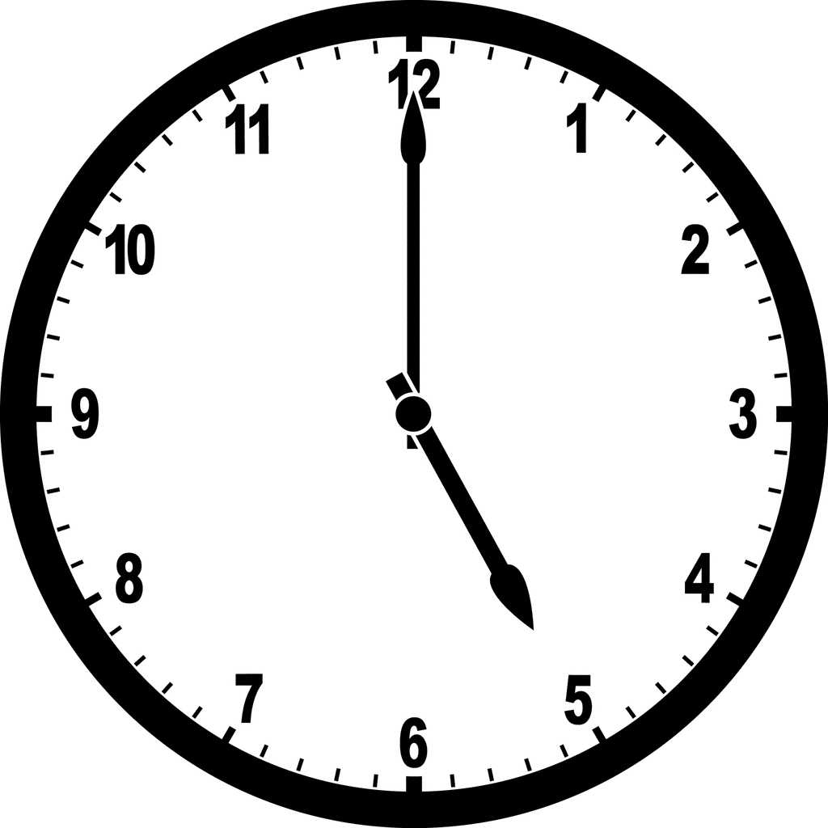

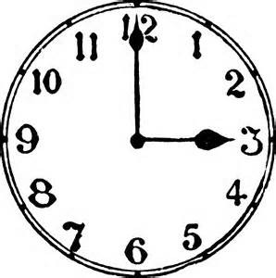

4. What are the following times in English? Please show the times by drawing a clock……

Kamachin Aciye

Pesk Aciye

Kwotinsk Aciye

Elewikenek

Vocabulary
Please translate the following words:
- Skitap Answer:_____________________
- Ehpit Answer:_____________________
- Kwapit Answer:_____________________
- Psowis Answer:_____________________
- Ahahs Answer:_____________________
- Towihpot Answer:_____________________
5 W’s
Word Bank: Who, where, when, why, what?
Mehsi? Answer:__________________________

Tama? Answer:__________________________

Kekw Answer:__________________________

Taywek? Answer:__________________________

Wen? Answer:__________________________
What are the following terms in English?
Word Band: Tree, owl, night, mice, hunt
Tihtәkәl Answer:__________________________

Kәtonhke Answer:__________________________

Әpәsihk Answer:__________________________

Nipayiw Answer:__________________________

Tokis Answer:__________________________

Please match the following 5 w’s with their proper match by placing the corresponding letter next to the word.
a) Wen ____Tokis
b) Taywek ____Tihtәkәl
c) Tama ____ Nipayiw
d) Mehsi ____ әpәsihk
e) Kekw ____kәtonke

WEATHER PATTERNS
Please translate the following English weather patterns into Maliseet (use your notes if you would like):
- Sunny:_____________________________
- Cloudy:_____________________________
- Snowy:_____________________________
- Windy:_____________________________
- Rainy:_____________________________
- Foggy:_____________________________
- Cloudy:_____________________________
- Cold:_____________________________
- Hot:_____________________________
- Nice Day:_____________________________
__________________________________________________________
TPASKOTIKӘNӘL
Circle the correct answer:
What number is Peskw?
a) 3
b) 5
c) 1
What number is Nihi?
a) 3
b) 8
c) 7
What number is kamahcin?
a) 8
b) 2
c) 6
What number is nis?
a) 9
b) 10
c) 2
What number is new?
a) 8
b) 4
c) 7

What number is kwotinsk?
a) 10
b) 5
c) 3
What number is nan?
a) 6
b) 5
c) 9
What number is Әlәwikәnәk
a) 7
b) 4
c) 9
What number is Eskwәnatek
a) 9
b) 3
c) 8

What number is Okәmolcin?
a) 8
b) 10
c) 5

What are the following numbers in W’last’kwey:
- 30
- 23
- 54
- 32
- How old are you?

